**Abstract:**

With proper knowledge of any companies stock and insight, one can gain large profit sitting at home. Stock market of a company is a time series data and stock trend/price prediction is one of the field where many researchers had gathered interest to predict the stock prices or trend in future using historical data and technical indicator with high accurately. **A good prediction model of a stock's future price will increase trader’s profits. In this report, the proposed model uses two different deep learning models** LSTM - Long short term memory to predict the stock trend**.**

***Index Terms–* Long Short Term Memory, Historical Data, Technical Indicators and Stock trend or price Prediction**

1. **Introduction**

Stock price prediction is a topic that attracts many data researchers and data analytics as a good stock prediction can capitulate notable profit. Stock of a company cannot just be predicted easily Stock market is something that changes randomly and finding patterns in stock is a very difficult task. This random change in the stock market is referred as random-walk behavior of stock prices with time. Firstly for prediction of any stock price, we analyze the data. For analysis two indicators are used Fundamental and technical indicators used to forecast stock prices. After analyzing the data various linear and non-linear models are being used to predict the data like ARIMA (auto regressive model) and ANNs. Artificial Neural networks ANNs like RNN, CNN, and LSTM are commonly used model in stock price prediction [1]. These Models are widely used in areas like Image Processing, Natural Language Processing, Time Series Analysis, etc. Over-fitting and under-fitting of data is a big problem while using ANN model for stock price prediction [2]. While non-linear model are better choice to predict stocks, many factual researchers had shown that non-linear models might not outperform linear models every time [3] [4] [5].

In this model, I have implemented LSTM model. Among all RNN architectures, LSTM is the most Important Model because of the introduction of memory cell. In this model, the information flows through a mechanism known as cell states. Due to these memory cells now, LSTM selects and remember or forget things According to its importance. Therefore, LSTM can learn and identify patterns of data dynamically with time and produces huge prediction accuracy.

1. **Methodology**

For Prediction of Stock Market, we need to deal with huge historical data that is highly nonlinear. To deal with this high non-linearity we need to find hidden pattern in our data and analyze them for prediction of future prices. Yet pattern identification given a nonlinear data is a trivial task and therefore there is a need of a dynamic model that could analyze our data and find all the hidden patterns. ANNs are very useful and capable of finding all the hidden patterns and exploit the data to predict the future prices through self-learning process [6]. These Neural networks are very efficient to predict the stock future prices and therefore are widely used. To predict a financial time series data Using Neural networks was intoduced in [7]. In this report, I have used Long Short Term Memory as a prediction model to predict the stock price of Netfix using Historical data.

In this report I have divided the prediction approach into subtopics and the subtopics are as follows:

Data Gathering, data processing which include Technical Analysis Feature Extraction and Feature Selection, Prediction and error analysis.

Data Gathering

All the data has been collected from yahoo finance website and downloaded under the historical data section [8]. This Historical data is used to predict the future stock prices.

Data processing

The historical data downloaded from yahoo finance was the raw unprocessed data with high volatility. Prediction using this raw data is not a good option so first we need to process this data. Therefore, I have calculated technical indicators [9]. Technical Indicators are the detailed study of past Market action for the purpose of forecasting future prices. It helps in forecasting the price direction and the current trend.

1. Simple Moving Average
2. **Exponential Moving Average**
3. **Moving Average Convergence/Divergence (MACD)**
4. **Triple Exponential Moving Average**
5. **Bollinger Bands**
6. **%b**
7. Average True Range (ATR) : measure of Volitality
8. **Keltner Channels**
9. Kaufman's Adaptive Moving Average (KAMA)
10. Average Directional Index (ADX)
11. Coppock Curve
12. **True Strength Index (TSI)**
13. Chandelier Exit
14. **Rate Of Change(ROC)**
15. **Chande Momentum Oscillator (CMO)**
16. **Stochastic %k (STCK)**
17. **Stochastic %D (STCD)**
18. **Relative Strength Index (RSI)**
19. **Williams %R**
20. **Money Flow Index(MFI)**
21. **Chaikin Money Flow**
22. **Accumulation Distribution Oscillation (ADO)**
23. **Chaikin Oscillator**
24. **Aroon Oscillator**
25. Commodity Channel Index (CCI)
26. **Percentage Price Oscillator**
27. Elder-ray
28. **Ultimate Oscillator**
29. Force Index (FI)
30. Ease of Movement EVM
31. **On Balance Volume (OBV)**
32. **Percentage Volume Oscillator(PVO)**

These were all the technical indicators out of which some of them were selected to further predict the stock prices. We cannot used all these features to predict the future price of the data the reason being the cost of computational time we cannot afford a pretty accurate result on the cost of giving much of our time. There we only need to select those features that are related to our stock price and we could discard other features. The selection of features was based on the correlation of all these features with the original stock prices. The features with highest correlation value were selected. The correlation techniques used over here were Scatter diagram and Pearson Correlation value. Scatter diagram is a graph which represents the relation between to dataset. In this graph the values of the two dataset are plotted along the two axes and the pattern of the resulting graph gives a basic idea about the correlation between the two dataset.

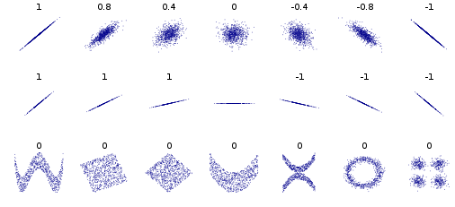Pearson Correlation assigns a number to the extent of relation between two dataset. Its value lies from -1 to 1, 1 representing exactly linear relation between two dataset and 0 representing no relation.

Figure 1 Scatter diagram and different types of relationships

After getting the best feature, the next thing we do is data transformation. Data transformation is used to normalize the data and make the data stationary which helps in pattern finding. The data was transformed/mapped in the range 0 to 1.

After the dataset is transformed into a clean dataset, the dataset is divided into training and testing sets so as to evaluate the prediction accuracy of my model. The training set is 90 to 95 percent of the total dataset and the testing data is the rest of the data left which is 5 to 10 percent.

Training the neural network:

After normalizing the data this data was fed into the LSTM network for training. The model was trained for 40 epochs and a batch size of 32. Initially the number of epochs were 100 and changed to find a good prediction model. This LSTM model was initialized of an input sequential layer lead by 4 LSTM layers and then finally a dense output layer with adam optimizer.

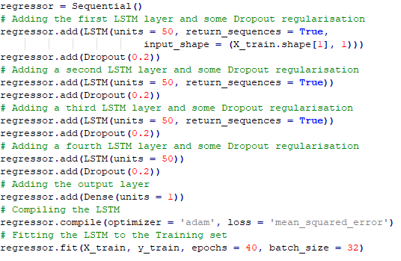

Figure 2 LSTM Model

**LSTM Architecture**

One of the main drawback of RNN was it cannot have long-term dependencies so it will not remember any information for long-term. This problem is known as Vanishing gradient problem. LSTM is very useful for long-term dependencies. In LSTM architecture, the LSTM cells are the part of the hidden layer. A LSTM cell comprises of Input gate/Update Gate, output gate and Forget gate. It also has two functions tanh and sigmoid function used for prediction.

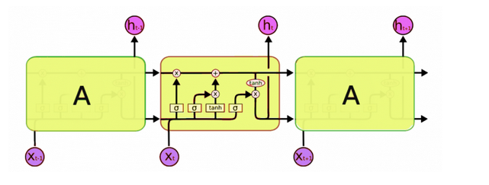

Figure 3 LSTM cell [10].

Equations governing the working of LSTM

$$Г_{u}= σ(W_{u}\left[a^{<t-1>},x^{<t>}\right]+ b_{u})$$

$$Г_{f}= σ(W_{f}\left[a^{<t-1>},x^{<t>}\right]+ b_{f})$$

$$Г_{o}= σ\left(W_{o}\left[a^{<t-1>},x^{<t>}\right]+ b_{o}\right)$$

$${\tilde{c}}^{<t>}=\tanh\left(W_{c}\left[a^{<t-1>},x^{<t>}\right] + b_{c}\right)$$

$$c^{<t>}= Г_{u} *{ \tilde{c}}^{<t>}+ Г_{f} * c^{<t-1>}$$

$$a^{<t>}=Г_{o} * \tanh{c^{<t-1>}}$$

There are two functions sigmoid ($σ$) and $tanh$ function used for the learning process.

The three gates have sigmoid function and the value of sigmoid function ranges from 0 to 1. And usually the values for this function is near to 0 or near to 1. The new activation cell and memory cell uses tanh function and the value of tanh function varies in range -1 to 1. And Usually the values of this function is near to -1 and 1.

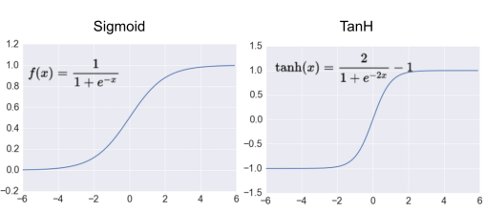

The forget gate decides whether to forget the current value of the activation cell or not. If the output of the forget gate is 0 then by multiplying it with the current activation state we can forget the activation cell else if the value of the forget gate is 1 then, the information is kept in the cell.

The input gate decides whether we need to remember the previous activation cell or to forget it. If the output of the input gate is 0 it means forget the previous activation cell and if the value of the input gate is 1 it means keep the value of the activation cell.

${\tilde{c}}^{<t>}$ is the new information that we may store in the cell memory. We have the tanh layer that outputs the candidate values for the cell memory, that could be added it the next step.

$c^{<t>}$ will decide the cell state which we will send in the next layer. It is the summation of $Г_{u} * { \tilde{c}}^{<t>} \& Г_{f} * c^{<t-1>}$ also the values of $Г_{u}\& Г_{f}$ are 0 or 1.

**Experimental Result**

|  |  |
| --- | --- |
| Parameter | RMSE |
| Train | **2.5983488911838393** |
| Test | **6.39236469202595** |

**Rmse percentage for training = 0.280695609385355**

**Rmse percentage for testing = 0.019395564077260306**

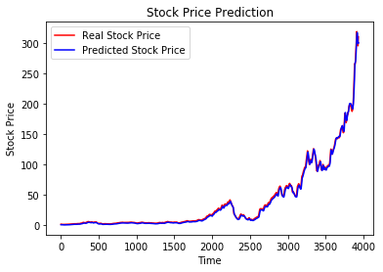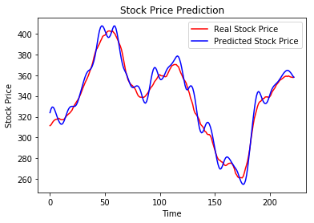

After performing continuous simulations for different number of features and epochs, we have observed that by taking MA14 feature with 49 epochs we are able to achieve nearly the best results with training RMSE of **2.5983488911838393** and testing RMSE of **6.39236469202595.**

**Conclusion**

Forecasting stock prices are very much helpful for investors to earn huge profit. Predicting future price of a given stock to produce an accurate result is encouraging researchers to find some new technique to improve the accuracy. RNNS like LSTM are very good in processing sequential time series data. LSTM has been proven a very good solution while dealing with sequential data streams. In this work, we have been able to produce significantly good result using a sliding window approach and LSTM model to predict the future price of Netflix stocks.

**References:**

[1] Olivier C., Blaise Pascal University: “*Neural network modeling for stock movement prediction, state of art”*. 2007

[2] Leng, X. and Miller, H.-G. : “*Input dimension reduction for load forecasting based on support vector machines”*, IEEE

[3] Lee, C. , Sehwan, Y. , & Jongdae, J. (2007). Neural network model versus sarima model in forecasting korean stock price index (kospi). *Issues in Information System, 8* (2), 372–378

[4] Lee, K. J. , Chi, A. Y. , Yoo, S. , & Jin, J. J. (2008). Forecasting korean stock price index (kospi) using back propagation neural network model, bayesian chiao’s model, and sarima model. *Academy of Information and Management Sciences Journal, 11* (2), 53 .

[5] Adebiyi, A. A. , Adewumi, A. O. , & Ayo, C. K. (2014). Comparison of arima and artifi- cial neural networks models for stock price prediction. *Journal of Applied Math- ematics, 2014*

*[6]* “*STOCK PRICE PREDICTION USING LSTM, RNN AND CNN-SLIDING WINDOW MODEL”* Sreelekshmy Selvin, Vinayakumar R, Gopalakrishnan E.A, Vijay Krishna Menon, Soman K.P

[7] H. White, Economic Prediction Using Neural Networks: The Case of

IBM Daily Stock Returns, ser. Discussion paper- Department of Economics

University of California San Diego. Department of Economics,

University of California, 1988.

[8] <https://in.finance.yahoo.com/>

[9] https://stockcharts.com/

[10] http://colah.github.io/posts/2015-08-Understanding-LSTMs/